Optimizing Pumping Systems Guidebook

From Pumps Systems Matter and the Hydraulic Institute (2008)

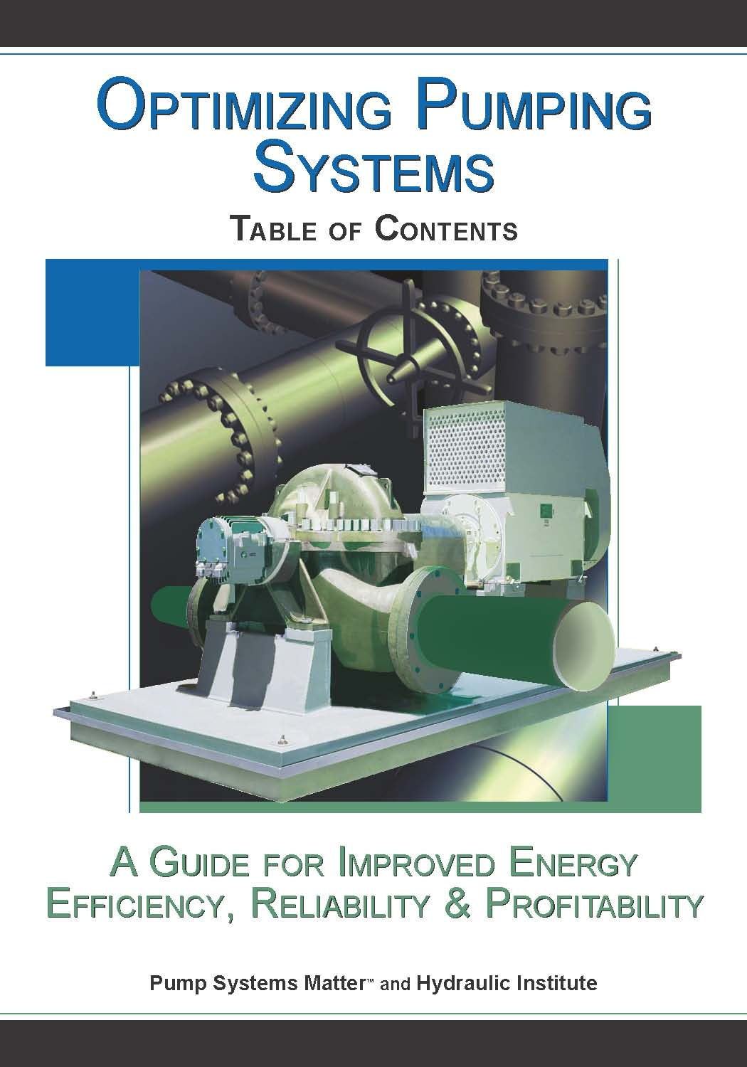

Twenty-two industry experts have compiled a comprehensive book on optimizing pumping systems. Energy losses in the pumping system as a whole are often greater than energy losses in the pumping unit. Read this book to learn how optimizing both existing and new pumping systems and purchasing based on life cycle costs will lead to increased profitability through a reduction in unnecessary, expensive energy consumption and maintenance costs.

Optimizing Pumping Systems includes:
• Executive Summary
• Chapter 1 – Pump Fundamentals
• Chapter 2 – Pump and System Interaction
• Chapter 3 – Calculating Cost of Ownership
• Chapter 4 – Improving the Performance of Existing Pumping Systems
• Chapter 5 – Building Better Pumping Systems: Optimizing New Designs
• Chapter 6 – Pumping System Economics—Opportunities to Improve Life Cycle Performance
• 13 page Glossary of Terms
• Case Studies

The book is now available from the Europump General Secretariat for 140 euro per copy plus postage. Please order using the following form.

Optimizing Pumping Systems
A Guide for Improved Energy Efficiency, Reliability & Profitability

Price : €140 per copy + postage (charged at cost)

Please send us .....................copies Total order amount : €................ + postage

Payment method

❍ Bank transfer on receipt of invoice
or
❍ Credit card :
O AMEX O Master Card O Visa Name on card
Card Number Expiry date
Date Signature

Name

Company

Address

Phone Fax

E-mail

Signature Date

